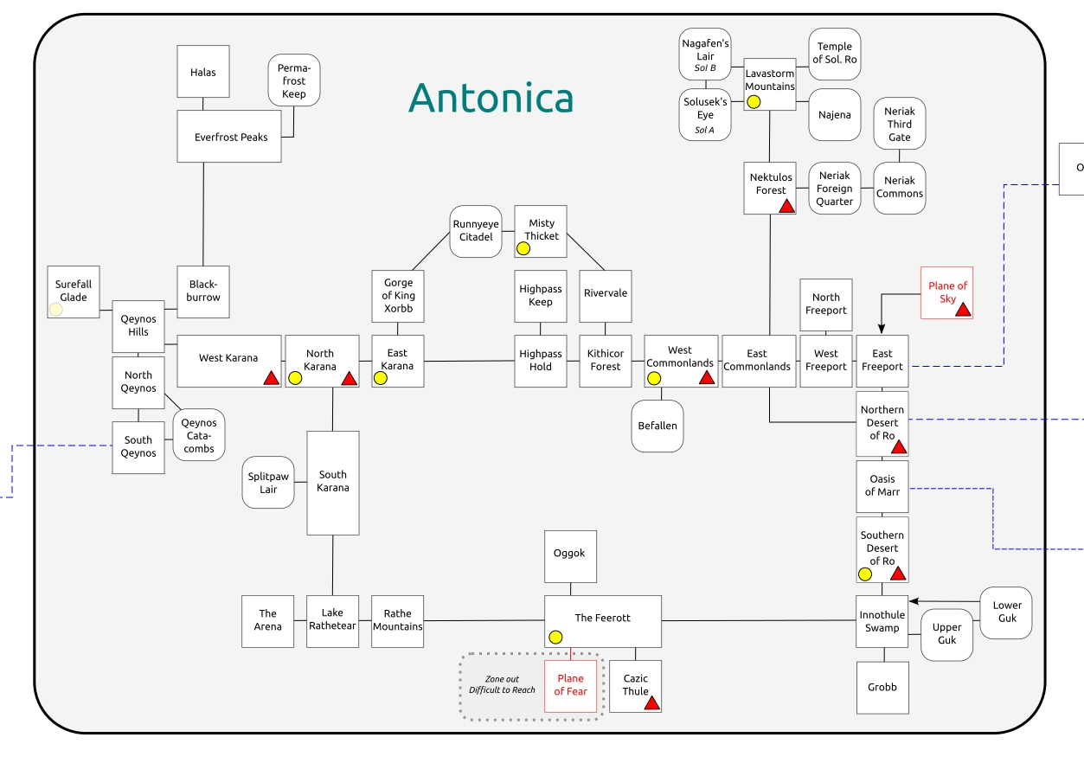

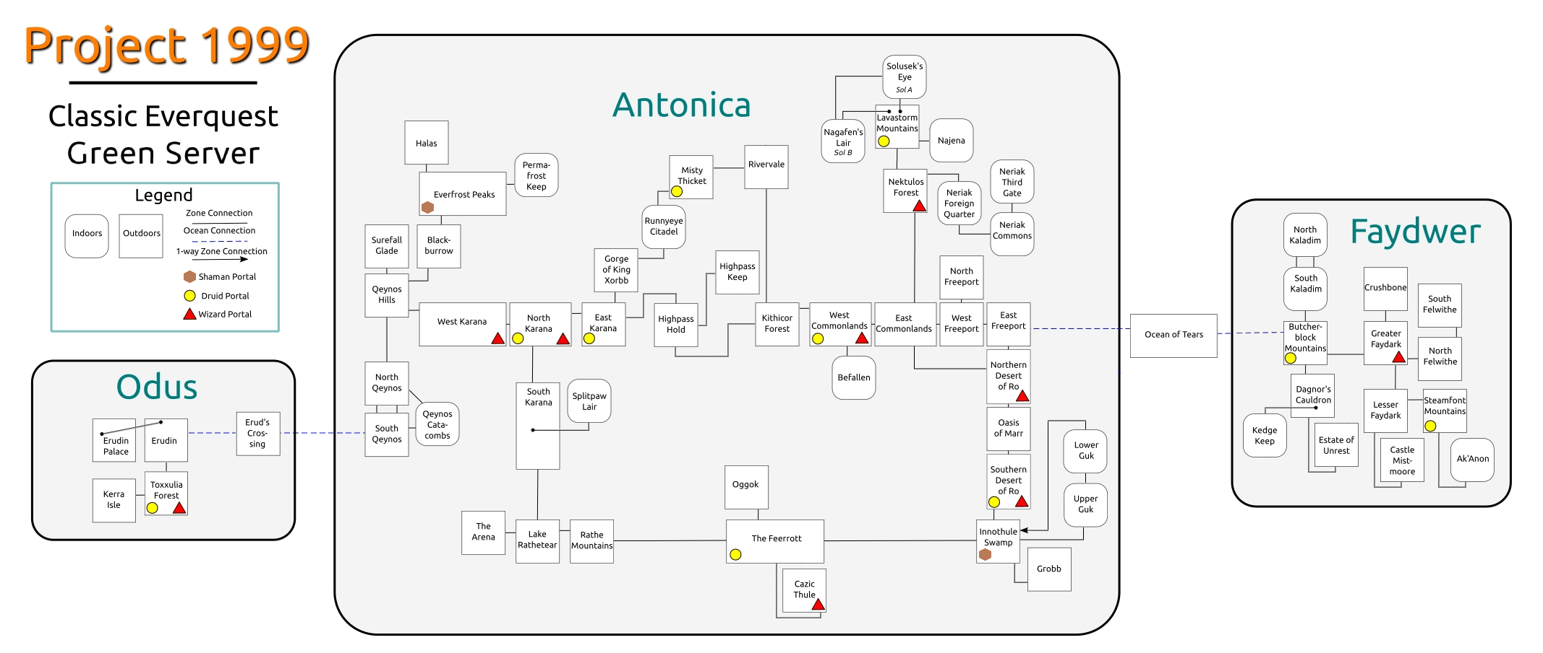

**Eastern Antonica**

**East Commonlands**

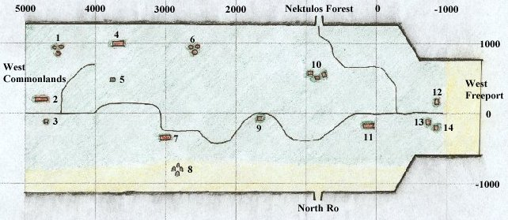

* 1. Orc Camp **("Orc 2")**
* 2. Inn with Alcohol, Cloth Armor, [Magician](https://wiki.project1999.com/Magician) Books, Spell Components, Tiny Daggers, and Gems **(Inn 4)**
* 3. Hut with Shields, Food, Herbs, and Compass
* 4. Inn with Arrows and Nocks, Alcohol, and Cloth Armor **(Inn 3)**
* 5. Obelisk with Rangers
* 6. Orc Camp **("Orc 1")** with Lord Shin Ree
* 7. Juna's Inn with Food, Alcohol, and Cloth Armor **(Inn 2)**
* 8. Haunted Ruins
* 9. Empty Hut
* 10. Plagued Huts
* 11. Harold's Inn with Food, Alcohol, Cloth Armor, and [Pottery](https://wiki.project1999.com/Pottery) Supplies **(Inn 1)**, also [Baking](https://wiki.project1999.com/Baking) Supplies
* 12. Shop with Miscellaneous Weapons and Throwing Weapons
* 13. Shop with Spell Components
* 14. Shop with [Cleric](https://wiki.project1999.com/Cleric) Trainer

**West Commonlands**

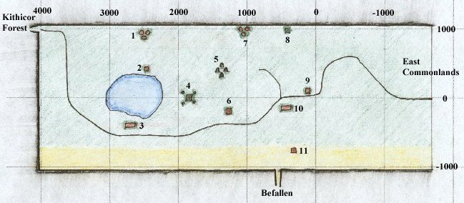

* 1. [Orc](https://wiki.project1999.com/Orc) Camp
* 2. Shop with [Fishing](https://wiki.project1999.com/Fishing) Supplies
* 3. Inn with Shields, Food, Alcohol, and Cloth Armor
* 4. Ancient Pyramid
* 5. Stone Rings with [Druids](https://wiki.project1999.com/Druid)
* 6. Empty Hut
* 7. Cutthroat Dervish Camp
* 8. Haunted Tower
* 9. "Toll Booth" - Guard House
* 10. Inn with Food, Alcohol, and Cloth Armor, Bags and Boxes nearby
* 11. Hut with Metals

**Rivervale**

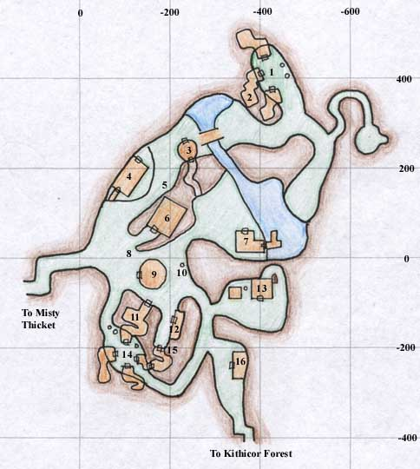

1. Pottery Wheel and Kiln

2. Nyla Gubbin's House

3. Merchants selling Bags and Fishing Supplies

4. Weary Foot Rest - Inn

5. Vale Forge

6. Town Hall and Leatherfoot Hall - Bank, Warrior Guild, Merchants selling Various Weapons

7. Merchants selling Food and other Goods, Fishing Supplies

8. Priest of Discord

9. Fool's Gold - Rogue Guild, Merchants selling Alcohol, Brew Barrel

10. Merchant selling Cloth Armor, Brew Barrel, and Loom

11. Merchants selling Potions and Crystals

12. Merchant selling Leather Armor and Patterns outside, Small Chain Armor and Small Chain Armor Patterns

13. Druid Guild with Merchants selling Ore, Veggies, Druid Weapons, and Druid and Ranger Spells, Forge and Oven outside

14. Pottery Wheel and Oven, Fletching and Bowyery Equipment, Weapon Molds

15. Merchant selling Potions and Crystals

16. Cleric and Paladin Guilds with Merchants selling Blunt Weapons and Cleric and Paladin Spells

**Nektulus Forest**

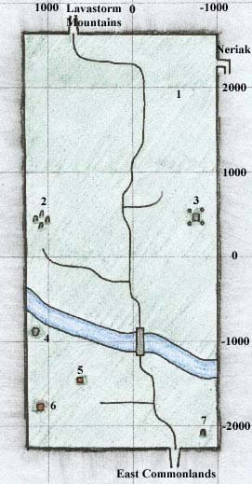

* 1. Newbie Area
* 2. [Halfling](https://wiki.project1999.com/Halfling) Ruins
* 3. [Wizard](https://wiki.project1999.com/Wizard) Teleport with Undead
* 4. Halfling Druid Temple
* 5. Ruined Obelisk with [Shadow Men](https://wiki.project1999.com/Shadow_Men)
* 6. Halfling Camp
* 7. Obelisk with Undead

**Lavastorm Mountains**

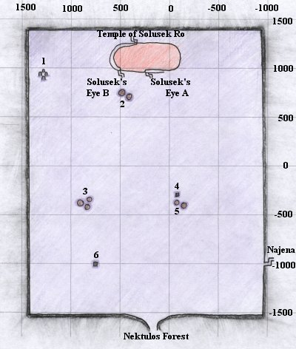

* 1. [Druid](https://wiki.project1999.com/Druid) Ring with Druid Merchant selling Druid Spells
* 2. Fire Goblin Camp
* 3. Gypsy Camp selling Combine Weapons, Fine Steel Weapons, Compasses and Earrings of Fire Reflection
* 4. Stone Obelisk
* 5. Goblin Camp where Hykallen appears
* 6. Stone Obelisk with [a shadowed man](https://wiki.project1999.com/A_shadowed_man)

**Solusek**

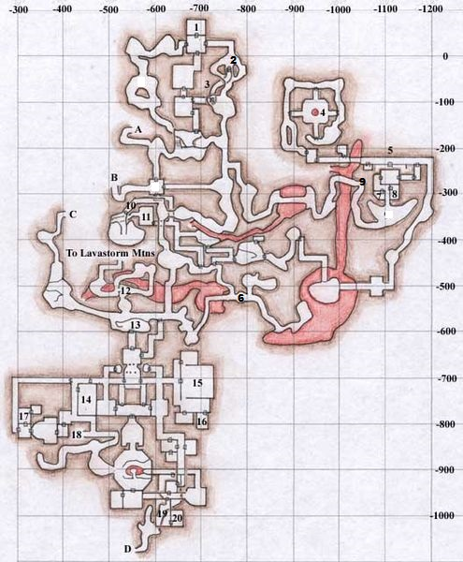



* 1. Room with [Inferno Goblin Captain](https://wiki.project1999.com/Inferno_Goblin_Captain) who drops [Charred Boots](https://wiki.project1999.com/Charred_Boots) (Common) and [Charred Gauntlets](https://wiki.project1999.com/Charred_Gauntlets) (Rare)
* 2. Room with [Kindle](https://wiki.project1999.com/Kindle) who drops [Obsidian Ring](https://wiki.project1999.com/Obsidian_Ring) (Common) and [Impskin Gloves](https://wiki.project1999.com/Impskin_Gloves" \o "Impskin Gloves) (Rare)
* 3. Efreeti Pits with Blazing Elementals and [Reckless Efreeti](https://wiki.project1999.com/Reckless_Efreeti) who drops [Platinum Armband](https://wiki.project1999.com/Platinum_Armband) (Common) and [Obsidian Flamberge](https://wiki.project1999.com/Obsidian_Flamberge) (Rare)
* 4. Lava Elemental Room with [lava elemental](https://wiki.project1999.com/Lava_elemental) who drops [Lava Potion](https://wiki.project1999.com/Lava_Potion) (Common) and [Runed Lava Pendant](https://wiki.project1999.com/Runed_Lava_Pendant" \o "Runed Lava Pendant) (Rare)
* 5. Doorway to upper level of the gnome fort (not shown) with [Captain Bipnubble](https://wiki.project1999.com/Captain_Bipnubble) who drops Brick of Blue Ore (Common) and [Gnomish Environment Suit](https://wiki.project1999.com/Gnomish_Environment_Suit) (Rare)
* 6. Room with [Singe](https://wiki.project1999.com/Singe) who drops [Obsidian Bead Hoop](https://wiki.project1999.com/Obsidian_Bead_Hoop) (Common) and [Drakescale Belt](https://wiki.project1999.com/Drakescale_Belt" \o "Drakescale Belt) (Rare)
* 7. Gnome Merchant named Marfen who sells [Bag of the Tinkerers](https://wiki.project1999.com/Bag_of_the_Tinkerers)
* 8. "Gabbie's Room" with [Gabbie Mardoddle](https://wiki.project1999.com/Gabbie_Mardoddle" \o "Gabbie Mardoddle) who drops [Mithril Quill](https://wiki.project1999.com/Mithril_Quill" \o "Mithril Quill) (Common) and [Molten Cloak](https://wiki.project1999.com/Molten_Cloak) (Rare) and CWG Model CX that drops Clockwork Oil Stout
* 9. Courtyard where spawns the wandering [CWG Model EXG](https://wiki.project1999.com/CWG_Model_EXG) who drops [Charred Guardian Shield](https://wiki.project1999.com/Charred_Guardian_Shield) (Common) and [Charred Guardian Breastplate](https://wiki.project1999.com/Charred_Guardian_Breastplate) (Rare)
* 10. Hallway with [Kobold predator](https://wiki.project1999.com/Kobold_predator) who drops [Kobold-Hide Boots](https://wiki.project1999.com/Kobold-Hide_Boots) (Common) and [Obsidian Shard](https://wiki.project1999.com/Obsidian_Shard) (Rare)
* 11. "Foreman's Room" with [flame goblin foreman](https://wiki.project1999.com/Flame_goblin_foreman) who drops [Foreman's Tunic](https://wiki.project1999.com/Foreman%27s_Tunic) (Common) and [Obsidian Scimitar](https://wiki.project1999.com/Obsidian_Scimitar) (Rare)
* 12. "Window Room"
* 13. "The Pit"
* 14. Room with [Goblin Merchant](https://wiki.project1999.com/Goblin_Merchant)
* 15. "Bar" with [Fire Goblin Bartender](https://wiki.project1999.com/Fire_Goblin_Bartender) who drops [Drake-Hide Leggings](https://wiki.project1999.com/Drake-Hide_Leggings) (Common) and [Drake-Hide Sleeves](https://wiki.project1999.com/Drake-Hide_Sleeves) (Rare)
* 16. "Drunkard Room" with [Fire Goblin Drunkard](https://wiki.project1999.com/Fire_Goblin_Drunkard) who drops [Frothy Goblin Tonic](https://wiki.project1999.com/Frothy_Goblin_Tonic) (Common) and [Fire Crystal Staff](https://wiki.project1999.com/Fire_Crystal_Staff) (Rare)
* 17. Room behind Throne Room with [Solusek Goblin King](https://wiki.project1999.com/Solusek_Goblin_King" \o "Solusek Goblin King) who drops [Ring of Goblin Lords](https://wiki.project1999.com/Ring_of_Goblin_Lords) (Common) and [Scepter of Flame](https://wiki.project1999.com/Scepter_of_Flame) (Rare)
* 18. Hallway leading to Jail, end of hall has [Inferno Goblin Torturer](https://wiki.project1999.com/Inferno_Goblin_Torturer) who drops [Turquoise Eyepatch](https://wiki.project1999.com/Turquoise_Eyepatch) (Common) and [Memento Box](https://wiki.project1999.com/Memento_Box) (Rare)
* 19. [Solusek Mage](https://wiki.project1999.com/Solusek_Mage" \o "Solusek Mage) room with bed
* 20. Room with [Lynada the Exiled](https://wiki.project1999.com/Lynada_the_Exiled" \o "Lynada the Exiled) who drops [Sparkle](https://wiki.project1999.com/Sparkle) Purse and [Goblin High Shaman](https://wiki.project1999.com/Goblin_High_Shaman) who drops [Glowing Stone Band](https://wiki.project1999.com/Glowing_Stone_Band) (Common) and [Platinum Dragon Totem](https://wiki.project1999.com/Platinum_Dragon_Totem) (Rare)

**Najena**

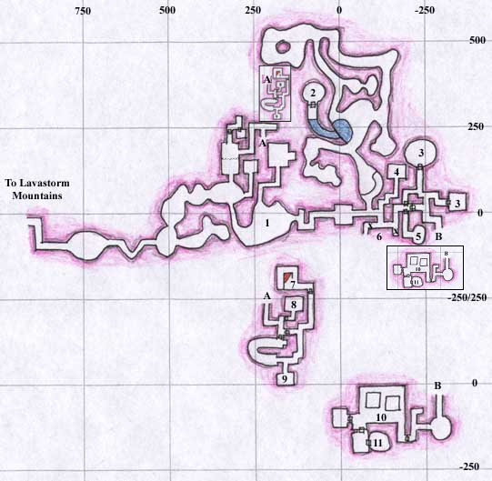

* Entry Room with Tentacle Terrors
* Najena's Room with Najena who drops Flowing Black Robe (Common), Clawed Knuckle-Ring (Rare), and Black Tome with Silver Runes Black Tome with Silver Runes
* Rooms
* Crystal Room
* Drelzna's Room with Drelzna who drops Stiletto of the Bloodclaw, Earring of Disease Reflection (Common) and Ashenwood Short Spear (Rare) and Golden Crescent Key to #2
* Pit Traps (marked with X) to room 10 below
* Magician's Lair, Trazdon's Room with Trazdon who drops Dark Circlet
* Bonecracker's Room with BoneCracker who drops Band of Flesh (Common), Barbed Leather Whip (Rare) and Leering Mask (Rare) and Dull Bone Key to #11
* Ogre Captain's Room with The Guard Captain who drops Ogre War Maul and Shiny Metal Key to cell outside of #11 and nearby Officer Grush who drops Dull Wooden Spear, and A Visiting Priestess
* Prison with Linara Parlone and An Injured Halfling in cell, Moosh wanders here
* Rathyl's Room with Rathyl who drops Travelers Pouch (Common), Travelers Pack (Rare) and Bloodstained Key to #5 and Rathyl reincarnate who drops Hollowed Bone Bracers, outside appears Ekeros who drops Blackened Sapphire.

Order to obtain keys:

* Go to (9) on map to get Shiny Metal Key
* Go to (8) on map to get Dull Bone Key
* Go to (11) on map to get Bloodstained Key
* Go to (5) on map to get Golden Crescent Key
* Go to (2) on map and kill Najena

**Northern Desert of Ro**

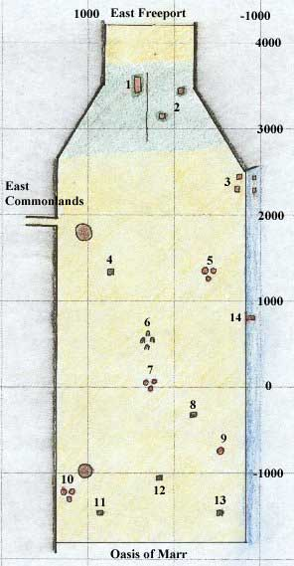

* 1. Inn with Thimble and Needle Molds, Large Sewing Kit, Food and Alcohol
* 2. Empty Huts
* 3. Fishing Village selling [Alchemy](https://wiki.project1999.com/Alchemy) Supplies
* 4. Buried Pyramid (the "platform"; is a wizard spire)
* 5. Dervish Camp with [Dorn B`Dynn](https://wiki.project1999.com/Dorn_B%60Dynn) - "Derv Camp One"
* 6. Haunted Ruins
* 7. Dervish Camp - "Derv Camp Two"
* 8. Ruins
* 9. Temple
* 10. Dervish Camp - "Derv Camp Three"
* 11. Pillar
* 12. Pillar
* 13. Ruins
* 14. Dock - Raft to Velious zones to Iceclad Ocean

**Oasis of Mar**

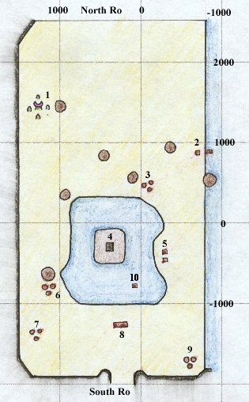

* 1. [Ogre](https://wiki.project1999.com/Ogre) Temple surrounded by Orcs
* 2. Abandoned Hut and Dock with boats to Kunark
* 3. Gypsy Camp with Combine Weapons, Food and Goods, Shaman Spells, and other Supplies
* 4. Temple surrounded by Spectres
* 5. Fishing Village
* 6. Cutthroat Dervish Camp
* 7. Cutthroat Dervish Camp
* 8. Inn selling Goods
* 9. Orc Camp
* 10. Aqua Goblin Tower

**Southern Desert of Ro**

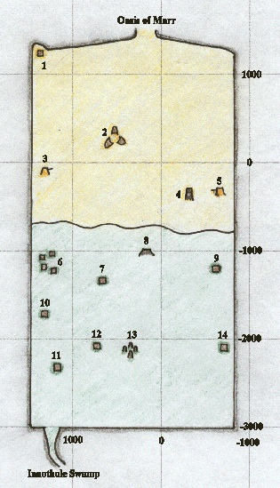

* 1. Home of [Ortallius](https://wiki.project1999.com/Ortallius" \o "Ortallius) and [Rathmana Allin](https://wiki.project1999.com/Rathmana_Allin" \o "Rathmana Allin)
* 2. Evil Merchants selling [Pottery](https://wiki.project1999.com/Pottery) Supplies (all), Combine Weapons
* 3. Dervish Camp
* 4. Ruined Temple
* 5. Dervish Camp
* 6. Orc Town
* 7. Orc Camp
* 8. [Wizard](https://wiki.project1999.com/Wizard) Portal
* 9. Orc Camp
* 10. Orc Camp
* 11. Orc Camp
* 12. Orc Camp
* 13. [Druid](https://wiki.project1999.com/Druid) Circle
* 14. Orc Camp

**Innothule Swamp**

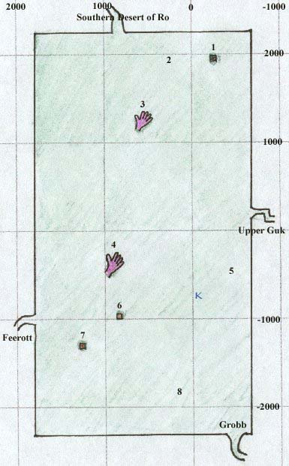

* 1. Tower, Home of [Jojongua](https://wiki.project1999.com/Jojongua" \o "Jojongua) and Fetid Froglok Ghouls
* 2. High level monsters (froglok foragers and kobold hunters)
* 3. Stone Hand where shaman spell vendor [Stragak](https://wiki.project1999.com/Stragak" \o "Stragak) is located
* 4. Stone Hand with shadowmen (-430, 980)
* 5. Froglok Hunting Grounds
* 6. Ruined Ferry
* 7. Submerged Hut
* 8. Newbie Area

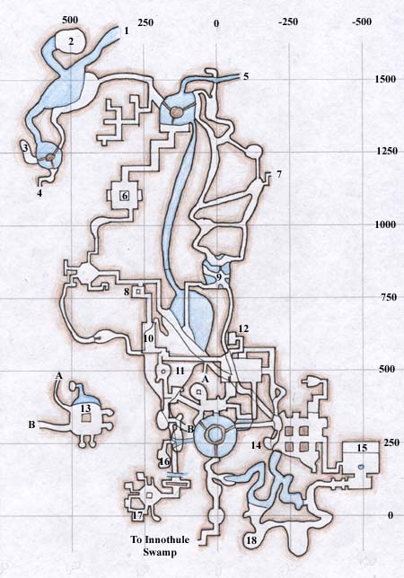

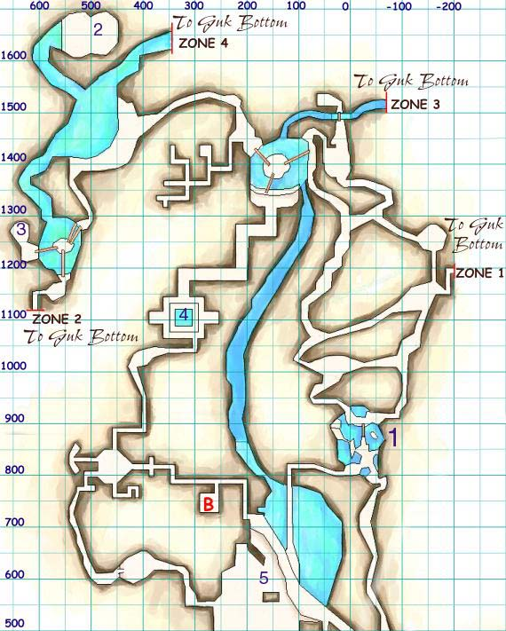

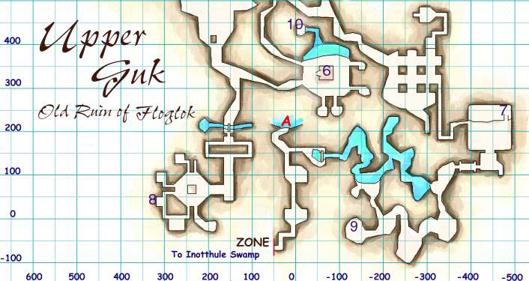

**Befallen**

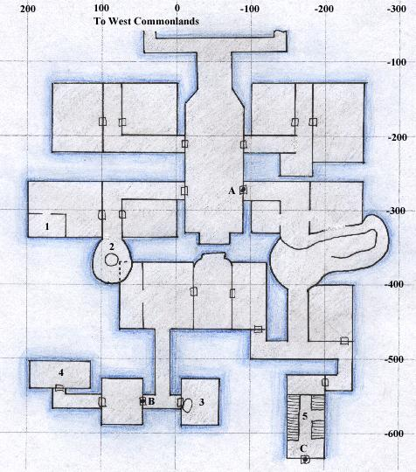

**Level One and Two**

* A. First locked door, requires [Splintered Wooden Key](https://wiki.project1999.com/Splintered_Wooden_Key) 1 -->A.
* B. Second locked door, requires [Charred Bone Key](https://wiki.project1999.com/Charred_Bone_Key) 3 --> B.
* C. Third locked door, requires [Smoked Glass Key](https://wiki.project1999.com/Smoked_Glass_Key) 4 -->C.
* 1. Dark Elf Shadow Knight who drops Splintered Wooden Key (Always) and [Chipped Bone Rod](https://wiki.project1999.com/Chipped_Bone_Rod) (Common)
* 2. [Skeleton Lrodd](https://wiki.project1999.com/Skeleton_Lrodd) and pit to area 1 on level 3
* 3. **PIT TRAP** Room with a [Human female Shadow Knight](https://wiki.project1999.com/A_shadowknight_(Human)) who drops [Charred Bone Key](https://wiki.project1999.com/Charred_Bone_Key), [Antiqued Silver Band](https://wiki.project1999.com/Antiqued_Silver_Band) (pit trap drops to area 4 on level 3)
* 4. [Ogre Shadow Knight](https://wiki.project1999.com/A_shadowknight_(Ogre)) who drops [Smoked Glass Key](https://wiki.project1999.com/Smoked_Glass_Key) (Always) and [Barbed Armplates](https://wiki.project1999.com/Barbed_Armplates) (Rare)
* 5. The Broken Stair

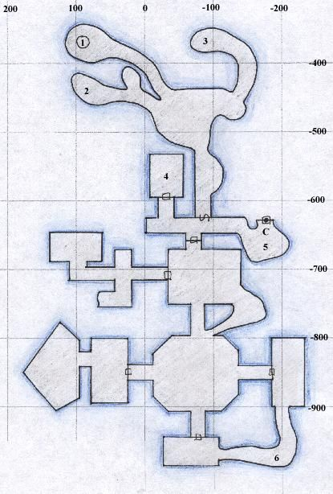

**Level Three**

* C. Locked door, requires smoked glass key
* 1. Pit from area 2 on level 1
* 2. Spawn area of [The Thaumaturgist](https://wiki.project1999.com/The_Thaumaturgist) who drops [Dagger of Marnek](https://wiki.project1999.com/Dagger_of_Marnek) (Common), [Gossamer Robe](https://wiki.project1999.com/Gossamer_Armor) (Uncommon) and [Thaumaturgist's Robe](https://wiki.project1999.com/Thaumaturgist%27s_Robe" \o "Thaumaturgist's Robe) (Rare) and [Damask Robe](https://wiki.project1999.com/Damask_Armor) (Rare), and [Priest Amiaz](https://wiki.project1999.com/Priest_Amiaz) who drops [Blackened Wand](https://wiki.project1999.com/Blackened_Wand) (Rare)
* 3. Spawn area of Troll Shadow Knight who drops [Bone Bladed Claymore](https://wiki.project1999.com/Bone_Bladed_Claymore) (Rare), [Smoked Glass Key](https://wiki.project1999.com/Smoked_Glass_Key) (Always), [Splintered Wooden Key](https://wiki.project1999.com/Splintered_Wooden_Key) (Always?), [Charred Bone Key](https://wiki.project1999.com/Charred_Bone_Key) (Always?)
* 4. Bottom of pit trap in area 3 on level 2
* 5. Spawn area of [An Elf Skeleton](https://wiki.project1999.com/An_Elf_Skeleton) who drops Thex Mallet Piece
* 6. Spawn area of [Dark Elf Female Shadow Knight](https://wiki.project1999.com/A_shadowknight_(Dark_Elf_Female)) who drops [Barbed Legplates](https://wiki.project1999.com/Barbed_Legplates) (Rare); can drop any of the keys of Befallen including [Splintered Wooden Key](https://wiki.project1999.com/Splintered_Wooden_Key), [Charred Bone Key](https://wiki.project1999.com/Charred_Bone_Key), and [Smoked Glass Key](https://wiki.project1999.com/Smoked_Glass_Key).

Note that in the room north of #6 is the spawn spot of [Boondin Babbinsbort](https://wiki.project1999.com/Boondin_Babbinsbort" \o "Boondin Babbinsbort) who drops [Icon of the Ardent](https://wiki.project1999.com/Icon_of_the_Ardent)

**The Feerott**

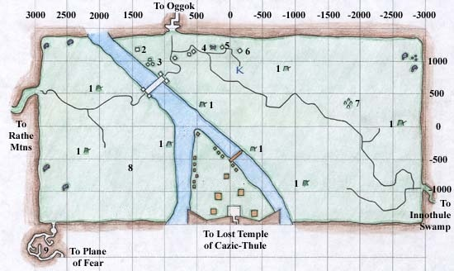

* 1. Lizard Man Camp
* 2. [Innkeep Gub](https://wiki.project1999.com/Innkeep_Gub" \o "Innkeep Gub) selling [Food](https://wiki.project1999.com/Food) and Miscellaneous Items
* 3. Merchants with [Bowyers Guide](https://wiki.project1999.com/Bowyers_Guide) and Materials and [Blacksmithing](https://wiki.project1999.com/Blacksmithing) Books and Molds
* 4. Half Moon shaped Altar
* 5. Merchant with [Cooking](https://wiki.project1999.com/Baking) Supplies
* 6. Merchant with [Large Sewing Kit](https://wiki.project1999.com/Large_Sewing_Kit) and [Tailoring](https://wiki.project1999.com/Tailoring) Supplies
* 7. [Druid](https://wiki.project1999.com/Druid) Ring surrounded by Spiders **\*Location: (410, -1850)\***
* 8. [Roror](https://wiki.project1999.com/Roror" \o "Roror) (Lizard Man Shaman, High Priest of [Cazic-Thule](https://wiki.project1999.com/Cazic-Thule" \o "Cazic-Thule)), will speak to good races, appears around this area
* 9. [Spectres](https://wiki.project1999.com/A_Spectre" \o "A Spectre) and Hidden Lair of [Cyndreela](https://wiki.project1999.com/Cyndreela" \o "Cyndreela), entrance to the [Plane of Fear](https://wiki.project1999.com/Plane_of_Fear) *Hidden Wall entrance at -1475,2690*
* **Levant location:** (+1091.63, +902.50) (near entrance to Ogguk

**Cazic Thule**

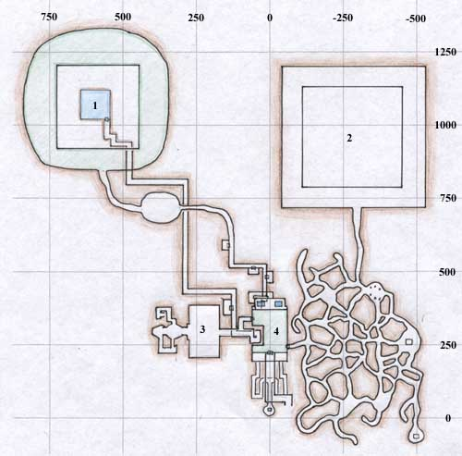

**Main Level**

* 1. Avatar of Fear Pyramid - top of pyramid spawns high level lizards, including Silvered Guards and [A Lizard Crusader](https://wiki.project1999.com/A_Lizard_Crusader), middle level is water-filled, bottom level is the green "gumdrop" with the AoF. You can fall between the levels.
* 2. Archon Pyramid - any level spawns [A Lizard Crusader](https://wiki.project1999.com/A_Lizard_Crusader) which drops decayed armor for [Darkforge Armor Quests](https://wiki.project1999.com/Darkforge_Armor_Quests" \o "Darkforge Armor Quests), top room spawns [Tae Ew Archon](https://wiki.project1999.com/Tae_Ew_Archon) which drops [Lizardscale Belt](https://wiki.project1999.com/Lizardscale_Belt" \o "Lizardscale Belt) (common) and [Ravenscale Armguards](https://wiki.project1999.com/Ravenscale_Armguards" \o "Ravenscale Armguards) (rare). You can reach the Archon using levitate, gaining enough height by running up one of the corner obelisks and then "bouncing" up the inwardly-slanted walls of the pyramid until you reach the roof. Before bouncing up, view the next level to make sure any patrolling lizard with see invisible walks away. The Archon uses a knockback spell so take care not be thrown into the pits below where you will surely be eaten by swarms of hungry gators. During busy times this area can support two groups, with "Archon CY" being the secondary camp, feeding off the obelisk lizards on the lowest level.
* 3. Throne Room or "TR" - see below
* 4. Courtyard or "CY"

**Rathe Mountains**

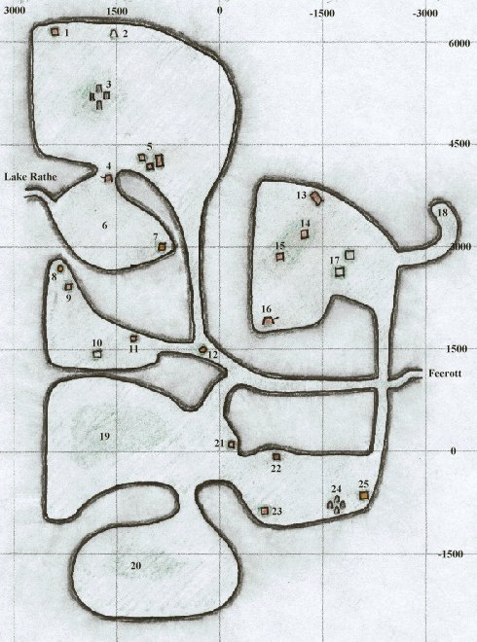

* 1. Orc Camp
* 2. Rune Stone with [Tabien the Goodly](https://wiki.project1999.com/Tabien_the_Goodly" \o "Tabien the Goodly)
* 3. Protected Stone Ring, surrounded by Unkempt Druids
* 4. Gypsies with Combine Weapons, Compass, Herbs and Food (Cynthia)
* 5. Inn, Hut with Merchant [Darfumpel Zirubbel](https://wiki.project1999.com/Darfumpel_Zirubbel" \o "Darfumpel Zirubbel) who sells Gems nearby.
* 6. Hill with Stone Arms reaching to the sky, Bandit Camp on top, Giant Skeletons and Lizard Men on sides of Hill
* 7. Haunted Tower with [Findlegrob](https://wiki.project1999.com/Findlegrob" \o "Findlegrob)
* 8. Altar protected by named beetles (Zaza)
* 9. Lizard Man Camp
* 10. Temple protected by Troll Shaman and Shadow Knight
* 11. Camp with Trolls and Ogres, selling Goods, Normal Weapons, and Leather and Small Sewing Kit and Patterns
* 12. Altar protected by named beetles (Ankh)
* 13. Inn
* 14. Orc Camp
* 15. [Paladin](https://wiki.project1999.com/Paladin) Camp
* 16. Gypsy Camp selling Food
* 17. Ruined Town with [Glaron the Wicked](https://wiki.project1999.com/Glaron_the_Wicked" \o "Glaron the Wicked)
* 18. Sphinx ([Ankhefenmut](https://wiki.project1999.com/Ankhefenmut" \o "Ankhefenmut))
* 19. Region filled with Hill Giants, Cyclops, and Giant Skeletons
* 20. Sphinx ([Zazamoukh](https://wiki.project1999.com/Zazamoukh" \o "Zazamoukh))
* 21. Lizard Man Camp
* 22. Lizard Man Camp
* 23. Orc Camp
* 24. Haunted Stone Ring. [Kazzel D`Leryt](https://wiki.project1999.com/Kazzel_D%60Leryt" \o "Kazzel D`Leryt) roams between here and the hill between 22 and 23
* 25. Haunted Tower with Bindlegrob and Sindlegrob

**Lake Rathetear**

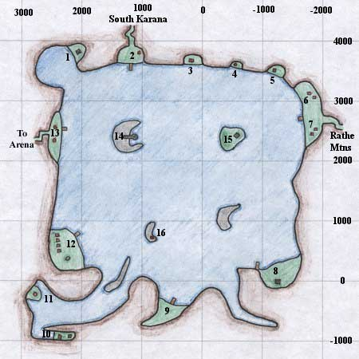

* 1. Guards and Abandoned Tower
* 2. Gnoll and Undead Camp (undead spawn at 8pm and despawn at 6am, replaced by low-level, generic gnolls)
* 3. Couple in Hut with [Turgan](https://wiki.project1999.com/Turgan" \o "Turgan) and [Shmendrik Lavawalker](https://wiki.project1999.com/Shmendrik_Lavawalker" \o "Shmendrik Lavawalker) part of Cleric Epic
* 4. Orc Camp and Barbarian Gathering
* 5. Bandit Camp
* 6. Ogre Camp, Ogre Merchant who sells Food and Goods
* 7. Bandit Camp
* 8. Tower with Stone Skeletons and pets, [Kazen Fecae](https://wiki.project1999.com/Kazen_Fecae" \o "Kazen Fecae)
* 9. Gypsy Camp selling Alcohol, Containers, Food and Miscellaneous Items
* 10. The "Friendly" Hermit
* 11. Aviak Lookout Tower
* 12. [Barbarian](https://wiki.project1999.com/Barbarian) Village with nearby Temple, also Shaman Armor Quests
* 13. Aviak Lookout Towers
* 14. The Aviak Ladder and spawn spot of [Webclaw Murkwave](https://wiki.project1999.com/Webclaw_Murkwave" \o "Webclaw Murkwave), has underwater cavern with two entrances with Aqua Goblin tower in the center of it, connects to tunnel under #15, tower is where [Deep](https://wiki.project1999.com/Deep) and [Lord Bergurgle](https://wiki.project1999.com/Lord_Bergurgle) are
* 15. Tower with silent spellcasters, has underwater cavern with two entrances with Aqua Goblin tower in the center of it, connects to tunnel under #14. [Eldreth](https://wiki.project1999.com/Eldreth" \o "Eldreth) for the Rogue Epic can also be found here.
* 16. Aviak Lookout Tower

**Western Antonica**

**Northern Plains of Karana**

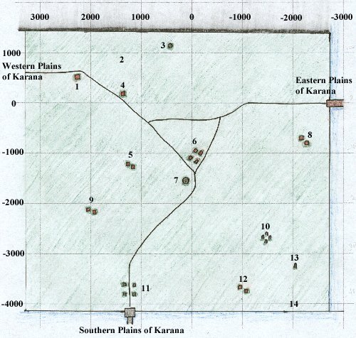

1. Hut with Alcohol

2. Area Patrolled by the Fangbreakers

3. Obelisk with named Treant nearby

4. Hut with Innkeepers selling Food and Goods

5. Empty farm

6. Gypsy Camp selling Combine Weapons, Alcohol, Food and Goods, Dreadlands Gate Spell, Bind Spot circa Mar 2001 [[2]](https://www.project1999.com/forums/showthread.php?t=337060)

7. Guard Tower

8. Farm with farmers

9. Farm with farmers

10. [Druid](https://wiki.project1999.com/Druid) Ring with Treants, [Druid](https://wiki.project1999.com/Druid) Trainer and merchant selling Druid Spells -2750,-1450

11. Wizard Teleportation Ring

12. Farm with farmers

13. Obelisk with Ghouls

14. Raider Camp

**Eastern Plains of Karana**

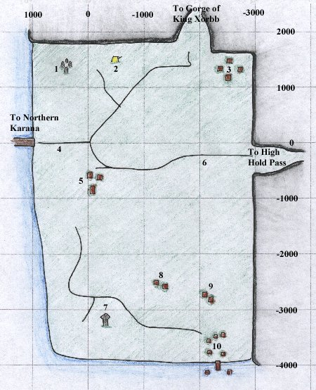

1. Druid Ring with [Druid](https://wiki.project1999.com/Druid) and Treant

2. Bandit Camp

3. Shops selling Weapons, Food, Goods, and Cloth Armor

4. [Sir Morgan](https://wiki.project1999.com/Sir_Morgan) (wanders east down the road and back)

5. Shops selling Archery Items and Food

6. Gnolls

7. Haunted Obelisk

8. Farm with farmers

9. Farm with farmers

10. [Barbarian](https://wiki.project1999.com/Barbarian) Fishing Village

**Southern Plains of Karana**

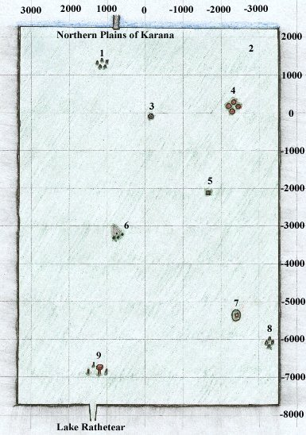

* 1. Undead Ruins with [Lord Grimrot](https://wiki.project1999.com/Lord_Grimrot)
* 2. Treants
* 3. [Vhalen Nostrolo](https://wiki.project1999.com/Vhalen_Nostrolo" \o "Vhalen Nostrolo)'s Well
* 4. Centaur Stables with Merchant selling Bowyer Supplies
* 5. Obelisk with Zombies
* 6. Entrance to [Splitpaw Lair](https://wiki.project1999.com/Splitpaw_Lair" \o "Splitpaw Lair)
* 7. Hermit House
* 8. Ruined Stone Ring
* 9. Aviak Town with Merchant [Krak Windchaser](https://wiki.project1999.com/Krak_Windchaser" \o "Krak Windchaser) (Top of Bird House)
* ([-5600, +150](https://wiki.project1999.com/South_Karana) [Map Icon.png](https://wiki.project1999.com/File:Map_Icon.png)) North-East of Aviak Town (#9): [High Shaman Grisok](https://wiki.project1999.com/High_Shaman_Grisok) or [High Shaman Phido](https://wiki.project1999.com/High_Shaman_Phido) or PH (for the [Monk Headband Quests](https://wiki.project1999.com/Monk_Headband_Quests)); spawn time is roughly 22 minutes

**Western Plains of Karana**

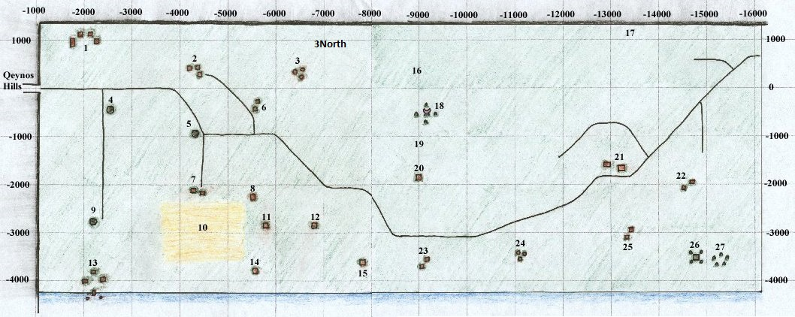1. Shops selling Cloth Armor, Cooking Supplies, Clay and Firing Sheets

* 2. Shops selling Throwing Daggers and Tailoring Patterns. [Innkeep Rislarn](https://wiki.project1999.com/Innkeep_Rislarn" \o "Innkeep Rislarn) selling Food
* 3. Bandit Camp (Bandits: Level 9-11). Note there is also a bandit camp ("3 North") just north and slightly east of Camp 3, near (890, -7050)
* 4. Guard Tower ("Tower 1")
* 5. Guard Tower ("Tower 2")
* 6. Farm taken over by Bandits and a Brigand (Bandits: Level 9-11)
* 7. Cleet Miller Farm
* 8. Empty farm
* 9. Guard Tower
* 10. Fields with Scarecrows (Undead Level 12-17)
* 11. Henina Miller Farm with Furball, also sells items
* 12. Empty farm
* 13. [Barbarian](https://wiki.project1999.com/Barbarian) Village selling Large Blacksmithing Molds and Books, Shaman Summon Spells
* 14. Tiny Miller's House
* 15. Farm with ex-Druid, Linaya Sowlin
* 16. Mountains filled with Bandits (Bandits: Level 9-11; the map makes it look more to the West than it is; loc is closer to 900, -11500)
* 17. Caninel with Gnoll Allies
* 18. Ogre Shrine guarded by [Ogre Guards](https://wiki.project1999.com/An_ogre_guard_(Karana)), [Ogre shamans](https://wiki.project1999.com/An_Ogre_Shaman) (ph's for, [An Ogre Priestess](https://wiki.project1999.com/An_Ogre_Priestess) & [Chief Goonda](https://wiki.project1999.com/Chief_Goonda)) (Ogres: Level 20-27 | Chief Level 34) respawns 22 minutes
* 19. [Froon](https://wiki.project1999.com/Froon" \o "Froon) and [Choon](https://wiki.project1999.com/Choon" \o "Choon) on a hill
* 20. Barbarian shop selling Fletching Kit, Arrows, Bows, and Nocks,
* 21. Shops selling [Blacksmithing](https://wiki.project1999.com/Skill_Blacksmithing) Books and Molds, also [Innkeep Danin](https://wiki.project1999.com/Innkeep_Danin" \o "Innkeep Danin) selling Food
* 22. Farms
* 23. Farms
* 24. Bandit Camp
* 25. Farms with Poison Merchant
* 26. Pyramid (Wizard portal)
* 27. Undead Ruins

**Qeynos Hills**

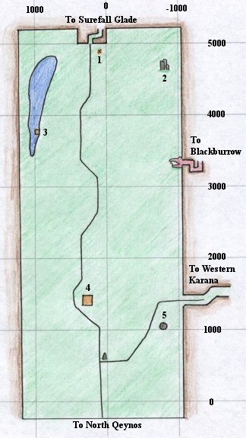

* 1. The Millers' Fire
* 2. The Haunted Ruins
* 3. [Hadden](https://wiki.project1999.com/Hadden" \o "Hadden) (6 hour Respawn) - chance to drop [Fishbone Earring](https://wiki.project1999.com/Fishbone_Earring)
* 4. Hut which sells [Smithing](https://wiki.project1999.com/Smithing" \o "Smithing) Books, Medium Armor Molds, Sectional Molds, and other smithing Molds, Sheet Metal
* 5. Guard Tower

**Surefall Glade**

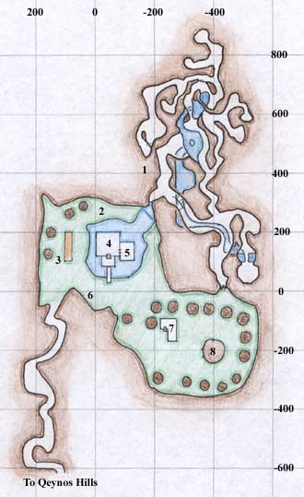

* Surefall Glade
* 1. The Caves filled with Bears and Mammoth
* 2. [Ranger](https://wiki.project1999.com/Ranger) Trainer
* 3. Archery Range with Ranger Trainer and Merchant who sells [Arrow-making](https://wiki.project1999.com/Skill_Fletching) Supplies
* 4. Ranger Hall with Ranger Guildmaster and Bard
* 5. Shop with Ranger Trainer and Merchants who sell [Bow-making](https://wiki.project1999.com/Skill_Fletching) Supplies, Bows, Throwing Weapons, Spells, Sharp Weapons, Food and Other Goods
* 6. Merchant selling Basic [Smithing](https://wiki.project1999.com/Skill_Blacksmithing" \o "Skill Blacksmithing) Molds
* 7. Jaggedpine Treefolk with Druid Trainer and Merchants who sell Arrow-making Supplies, Druid Weapons, Spells, Food and Other Goods
* 8. [Druid](https://wiki.project1999.com/Druid) Guildmaster and Surefall Druid Teleport destination

**Everfrost Peaks**

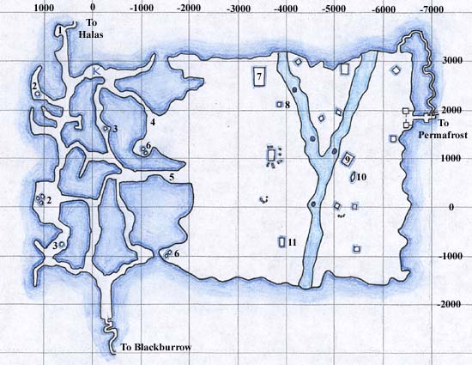

**Everfrost**

* 1. Merchants selling Large Sewing Kits, Sewing Supplies, and Goods
* 2. Ice Goblin Igloos with low-level spawns
* 3. Ice Goblin Igloos
* 4. [Barbarian](https://wiki.project1999.com/Barbarian) Guards
* 5. Bandl McMarrin -- Barbarian Guard
* 6. Ice Goblin Igloos with mid-level spawns
* 7. Temple with Barbarian Shaman selling Poison-based Spells
* 8. "North Tower" or "Megan's Tower"
* 9. Temple inhabited by Icy Orcs and [Redwind](https://wiki.project1999.com/Redwind" \o "Redwind)
* 10. Stone Giant Statue
* 11. "South Tower"

**Bear Caves**

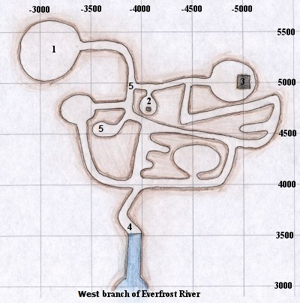

**Bear Caves**

* 1. Room with [Sulon McMoor](https://wiki.project1999.com/Sulon_McMoor" \o "Sulon McMoor), high level Necromancer
* 2. Ice Boned Skeletons with broken Teleporter
* 3. Ice Boned Skeletons in Building with Wizard Rod piece on ground
* 4. Entry Room with Ice Goblins
* 5. [a glacier bear](https://wiki.project1999.com/A_glacier_bear) spawn point

**Permafrost Keep**

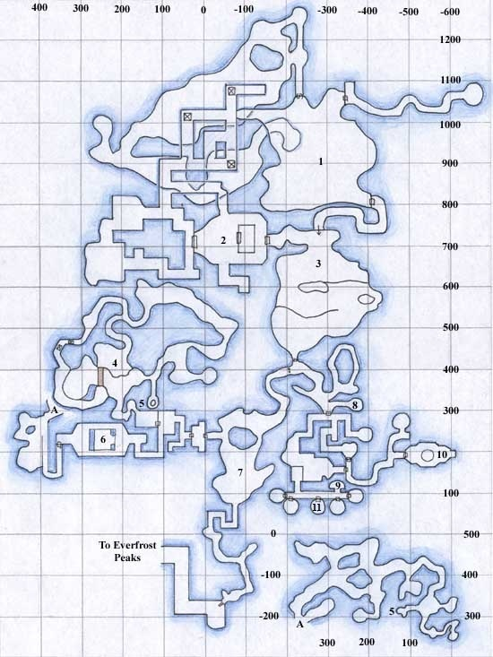

* 1) Lair of Lady Vox (see Raid Encounter page for drops)
* 2) Ice Giant Diplomat who drops Throwing Boulder, and Ice Goblin Champion who drops Crystalline Blade.
* 3) King's Room
* 4) Goblin Archeologist (Level 24-27) who drops Archeologist Pack (Common) and Dented Brass Mask (Rare)
* 5) Well that drops to sub-caverns shown at lower right
* 6) Goblin Preacher (Level 24) who drops Cold Iron Morning Star (Common) and Runed Circlet (Rare)
* 7) "Flag Room"
* 8) A goblin alchemist (Permafrost) (Level 27) who drops Mammoth Hide Leggings (Common) and Mammoth Hide Cloak (Rare)
* 9) Goblin Jail Master (Level 20) who drops Wooly Spider Silk Net (Common) and Etched Ivory Charm (Rare)
* 10) Goblin Scryer (Level 25) who drops Ice Crystal Staff (Common) and Wolf Fur Slippers (Rare)
* 11) An icy goblin (Level 24) who drops Book of Frost (rare)